Department of Statistical and Sociologic Analysis  of the Republic of Moldova  DASS | Institut Français  de  l’Environnement  Ifen

EUROSTAT
TACIS Project Environment Statistics
MD92FR01

INLAND WATER ACCOUNTS
OF THE REPUBLIC OF MOLDOVA
PRELIMINARY RESULTS OF RESOURCE ACCOUNTS IN RAW QUANTITIES, 1994 & 1998

FIRST ELEMENTS FOR ENVIRONMENTAL EXPENDITURE ACCOUNTS FOR PROTECTION AND EFFICIENT USE OF WATER

JULY 2000

Contents

Executive summary

Introduction

1. Statistics of water resources in the Republic of Moldova

1.1. Physical statistical parameters of water resources
1.1.1. Data on the water resource availability
1.1.2. Statistics on water resource utilisation
1.1.3 Water resources quality indices

1.2. Statistics on expenditures for protection and efficient use of water resources

2. Framework of environmental accounts of inland water

2.1. General system of water accounts
2.1.1. Accounts of resource and uses
2.1.2. Accounts of rivers in quality
2.1.3. Accounts of emissions and discharge to water
2.1.4. Accounts of expenditures and costs

2.2. Framework of accounts of water resource and uses in raw quantities

2.3. The environmental expenditure “satellite” accounts in the domain of water (SERIEE )

3. Accounts of water resource and uses in raw quantities, preliminary results for 1994 and 1998
3.1. Data sources, collection and processing
3.2. Tables for 1994 and 1998
3.3. Indicators of availability and intensity of use of the water resource computed from the accounts : results for the Republic of Moldova and comparisons with France and Spain

Conclusion : Problems and answers, recommendations for future developments

Annexes

1. Water resource accounts in raw quantities of the Republic of Moldova, Preliminary results 1994-1998
2. Detailed Classification of Assets, Flows and Sectors
3. Surveys by DASS-Moldova :

Executive Summary

The preliminary use of statistical data in the area of estimation of utilization and environmental protection of water resources (in both monetary and physical terms) in the Republic of Moldova, permits to state the following points:
- There is a system of statistical indices used for filling in tables with data on estimation of water resources in monetary and physical terms.
- The determination of the integral, basic indices of availability and use of water resources is crucial for estimation of the overall resources as well as use of water.
- The above calculations determined the weak areas of statistics on water resources and determined concrete indices, whose qualitative side evokes doubts regarding data reliability. This peculiarity requests revision of the entire process of data collection but also the need for determination of methodological terms which are part of these indices.
- The proposed system of environmental accounts can be submitted to policy makers and specially to the departments and agencies in charge of environmental protection for use in assessment of the current state of water as well as in the preparation of appropriate measures aimed at the reformation of management in the area of water resources, estimation of water resources use and determination of measures focused on prevention of water pollution.

Introduction

The feasibility study of water accounts for Moldova is one of the recommendations resulting from the mission by the Ifen expert in Chisinau, December 1999. During this mission, several points were clearly stated :

Water is a major environmental concern in Moldova, with health and economic consequences as well.
A rather important amount of statistics are collected by DASS, the Statistical Office of the Republic of Moldova, on a regular basis.
In addition, DASS launched some sampling surveys in order to bridge gaps in some key areas, in particular related to households and the environment .
On the other hand, discussions with water Authorities lead to the conclusion that the changes in the Transition period may result in difficulties with the current surveys, due in particular to the very quick increase in statistical units.

Accordingly, the usefulness of water accounts as a framework for securing some consistency between various data sources was considered and a test decided.

The results of the first preliminary accounts are encouraging. Two years have been computed, giving a vision of changes. These results have been compared to those obtained in France and Spain in similar studies.

Of course, there is no magic in accounting. The accounting techniques have to be considered as a tool for identifying gaps and a basis for deciding of rationale solutions for overcoming them. These solutions may be the improvement of current surveys, the development of sampling surveys, the development of the monitoring networks and/or the use of hydrological models. In every case they are based on a close inter-institutional co-operation, involving scientists and policy makers.

For this reasons, the present report has to be considered as a preliminary step. In order to facilitating a clear discussion, the reports presents not only the water accounts but also the sources of the data used (Chap. 1 and annexes) and some general information on the various types of water accounts (Chap. 2). In addition, a first set of indicators is presented and commented (Chap.4).

Statistics of water resources in the Republic of Moldova

  - Goals and objectives of statistical monitoring of water resources

Statistics of water resources can be defined as quantitative and qualitative estimations by means of a system of statistical indices, aimed at calculating and studying the availability, state and use of water resources.

On the whole, the system of statistical indices derived from the units of measurement can be represented as a subsystem of :
- physical parameters, characterizing reservoirs, distribution and use of water, state, impact and measures aimed to protect water resources, …;
- cost parameters, characterizing water value and costs of both enterprises and the community as a whole, related to efficient use as well as to the prevention of water resources pollution.

Water resources are the subject of statistical surveillance. The system of statistical indices of water resources is based on the current and annual statistical reported data and on materials of non-repeated surveys.

Water resources are usable waters, theoretically all waters of the Earth such as : river run-offs, pools, seas, groundwater, soil moisture, mountain and polar glacier ice, atmospheric water steam, except for incidental constituting minerals and bio-masses. Water resources statistics cover, in particular, such water units as seas, rivers, lakes, aquifers as well as man-made channels and reservoirs .

  - Physical statistical parameters of water resources

    - Data on water resource availability

Water resources of Moldova amount (average year) to 12,69 km³, including :
- 1,31 km³ being formed on the territory of the Republic
- 11,38 km³ coming from the neighboring territories

The estimated potential operational reservoirs in the Republic of Moldova constitute 0,92 km³ per year. Surface waters form half of them.

3,2 thousand of permanent and temporary watercourses, of which 9 are the rivers of more than 100 km length and 247 of more than 10 km length, flow over the territory of the Republic. The average annual water flow of the Nistru river is 10,2 km³, Prut river - 2,9 km³ . The water flow of all local small rivers is around 0,8 km³ per water-content-average year.

57 lakes with the total water surface area of 62,2 km² are located on the territory of the Republic. Small lakes - up to 0,2 km² - prevail. Apart from the natural lakes, there are more than 3,5 thousand of pools and reservoirs with the total volume of more than 1,8 km³ and the total area of around 160 km².

Total underground water resources are estimated at 1 km³, of which 60% were explored and registered in 108 deposits.

Available water resources in the territory of Moldova average 6,3 billion m³, in a dry season - 4,9.

The major sources of surface waters are fall-outs. The average annual precipitation totals 370 mm in the South and 560 mm in the North. The average density of the snow blanket varies from 0,18 to 0,25 g/cm³, water storage - from 30 to 50 mm. Oppressive heat and low temperatures, mild winter and cool summer, abundant rains and snowfalls, long droughts and hot winds, hailstones and ground frosts produce strong impact upon water reservoirs and, consequently, influence the formation of surface and underground waters.

Table 1. Meteorological data on the annual precipitation, Republic of Moldova, mm, 1994-1998
Regions | 1994 | 1995 | 1998
North | 456 | 609 | 890
Centre | 403 | 702 | 666
South | 383 | 401 | 584
Average | 414 | 571 | 713

The major sources of the above-mentioned data are:
- monitoring by the hydro-meteorological services
- observations made by science and research institutes in the in the field of geography, geodesy and hydrology;
- observations of sanitary and epidemiological services

    - Statistics of water resources utilization

Statistical observation of the process of water draw-off, consumption and discharge is made by the Agency “Apele Moldovei” (Waters of Moldova). The basic source of information is the data of the questionnaire on Water Utilization.

The questionnaire is forwarded to all enterprises and organizations, which off take, supply, consume and discharge waters in the territory of the Republic of Moldova, regardless of water supply sources and sewage receivers. Statistical observations have been organized and conducted since 1983. Primary data for the questionnaire are based on the measurements or estimations made by water consuming enterprises.

Combined data include a set of the following indices:
- water draw-off from the natural sources – total in m³ per year, including water from underground sources;
- use of water - total in m³ per year, including by consumption categories:
- municipal needs
- production needs
- agricultural needs
- irrigation
- water losses while in shipment and irrevocable water consumption - total in m³ per year,
- the quantity of discharged sewage - total in m³ per year, including by the pollution level
- normative-pure sewage
- normative-purified sewage
- polluted sewage

- the quantity of harmful substances discharged with sewage by 56 polluting ingredients, tons or kg per year.

Generalized information allows analyzing the issues and problems related to water consumption :
- at the regional level;
- according to the type of activities;
- individual water basins and concrete rivers.

Table 2. Main indicators on the use of water in Republic of Moldova, 1985-1998
 | 1985 | 1990 | 1994 | 1998
Water collection from water sources, mil m³ | 3745 | 3918 | 2682 | 1263
Water consumption, mil m³ | 3647 | 3827 | 2559 | 1176
Industrial purposes | 2676 | 2523 | 1585 | 767
Irrigation of agricultural lands | 643 | 898 | 621 | 92
Communal drinking purposes | 214 | 271 | 253 | 214
Agricultural water supply (stock-farming…) | 114 | 135 | 100 | 65
Circulating and consecutive water consumption, mil m³ | 766 | 977 | 63 | 453
Sewage disposed into surface water, mil m³ | 2943 | 2731 | 1810 | 1030
Standard-clean sewage not requiring treatment, mil m³ | 2679 | 2424 | 1547 | 802
Volume of sewage disposal, mil m³ | 41 | 90 | 16 | 12
Untreated | 8 | 1 | 0.4 | 0.4
Semi-treated | 33 | 89 | 15 | 12
Standard-treated waters | 223 | 216 | 247 | 215

The above subsystem of physical parameters allows characterizing the situation in the area of water consumption and protection, evaluating the organization of the corresponding data collection and reliability as well.

In conformity with the statistical data, more than 2,6 thousand enterprises and organizations of the Republic of Moldova off take waters from different water sources. In 1999, as compared to 1990, water draw-off from natural sources decreased by 70% and amounted to 1,2 billion m³ of water disregarding water used by the Moldavian hydroelectric station for cooling the generators. At the same time water losses while in shipment totaled 90 million cubic m (8% of annual draw-off) and 30 million m³ of potable water are used for the production purposes.

Sewage discharges into surface waters amounted the same year to 1.2 billion m³, of which 10.9 million m³ are polluted or 5% of total sewage volume subject to purification (in 1990 - 90 million m³ of 2.7 billion m³, or 30%, respectively). Polluted flows come in general from sewage treatment plants of municipal services and enterprises of the agro-industrial sector.

The observed decrease of water draw-off, consumption and sewage discharge was caused, first of all, by the shut-down and discontinuance of the activities of several production enterprises, i.e. by reasons of merely economic nature, not by the introduction or realization of any environmental measures.

It is noteworthy to mention, that statistical observation has been organized with regard to water draw-off, supply and treatment by municipal services for all categories of consumers, including population with the use of physical measurement units – cubic meters. The above observation is carried out by means of collecting annual reported data on the production and economic activities of communal water services in the country.

    - Water resources quality indices

Statistical observation of surface waters pollution has been conducted since the fifties by means of collecting daily information from observation stations by the hydro-meteorological services. On the basis of these primary data the estimation of some indices is made, including the major ones:
- the average annual concentration of pollutant in the locality, on the spot, in the river basin, mg/l
- media-variant, which corresponds to the probability rate of 50%, in %
- recurrence of pollutant content in the water higher than SCL (Standard Concentration Limit), 10SCL, 30SCL, 50SCL, 100SCL, %
- indices enabling to characterize the state of water for the purposes of compliance with the current norms and standards.

Table 4. Water resources pollution in the territory of the Republic of Moldova, 1998-1999
Year | Number of registered  high level  water pollution  occurrences | Ammonite nitrogen | Nitrate nitrogen
1994 | 54 | 22 | 32
1998 | 35 | 14 | 21
1999 | 20 | 8 | 12

Moreover, the evaluation of the state of water for the purposes of compliance with the health standards is made by the sanitary and epidemiological services of the Ministry of Health on the basis of the annual reported data on the activities of the sanitary and epidemiological services. In 1999 the sanitary and hygienic surveys were made on the basis of the taken samples.

Table 4. Indices of the sanitary and hygienic state of water – number of examined samples in the Republic of Moldova, 1999
Subject of survey | Sanitary and chemical indices | Registered non-observance of the established norms
Underground sources of the centralized water supply  1994  1998 | 3016  1335 | 1199  617
Surface sources of the centralized water supply  1994  1998 | 163  100 | 46  37
Sources of the decentralized water supply  1994  1998 | 7019  4973 | 4922  4101

Municipal water-pipes  1994  1998 | 6523  3628 | 896  835
Rural communal water-pipes  1994  1998 | 3968  967 | 900  232

  - Statistics on expenditures for protection and efficient use of water resources

Statistical surveillance on the use of water resources and distribution of water by different users: enterprises, population and others, is conducted by communal services. The regional agencies present reports to State statistical institutions on the economic activities of communal services. This reports include indices on:
- quantity of supplied and used water by various users, population and enterprises;
- income generated from the water supply and waste-water cleaning, marking the served beneficiaries;
- expenditures, incurred for activities of communal enterprises;
- capital investments, made in reconstruction of production systems of communal enterprises.

Statistical surveillance in protection of water resources is conducted by means of collection of annual statistical mail questionnaires, presented by enterprises and organizations, which have waste-water treatment facilities or perform water protection measures. The questionnaires are collected by regional statistical agencies by mail. The statistical questionnaire surveys information on the expenditures incurred for protection of water resources includes the following indices:
- Current expenditures, incurred for water protection and prevention of pollution of water resources.
- Funds, contributed by enterprises for water supply and waste-water cleaning.
- Funds, contributed by enterprises for capital reparation of waste-water cleaning facilities and water reservoirs.
- Payment of environmental taxes made by enterprises and institutions for water resources pollution.

The main source of information regarding the allocation and use of capital investments for protection of water resources is the statistical state report on “Use of Environmental Protection Investments”. These data are provided on a compulsory basis by all enterprises and organizations that invested or during the year incurred expenditures for establishment of water protection facilities or performed environmental protection activities. Summarizing the availability of data used for evaluation of expenditures incurred for protection and prevention of water resources pollution, it can be noted, that these data are sufficient for calculation and first estimation of water resources in financial terms.

The above can be presented in the table below:

Table 5. Statistical data about the environmental expenditures for water protection, Republic of Moldova, 1994, 1998
 | 1994 | 1998
Current expenditures on maintenance and use of environmental protection facilities and measures aimed at environmental protection at the industrial, agricultural, transport, communal and others on the protection and rational use of water resources, mil lei | 25.4 | 20.2
Total expenditures on the capital repairs on the facilities and equipment to treat sewage water and the rational use of water resources, mil lei | 2.6 | 4.1
Total capital investment on the protection and the rational use of the water resources (state), mil lei | 5.8 | 1.5
Payments from enterprises for communal services - consumption of drinking water and treated sewage water , mil lei | 17.8 | 47.4
Payments by enterprises of state water taxes for pollution, mil lei | 1.4 | 1.4
Expenditures for state environmental protection management agencies, mil lei | 3,6 | 7.1
Water tariff for communal services of drinking water and treated sewage water , lei per m³  For :  Enterprises and organizations  Drinking water  Sewage  Population  Drinking water  Sewage | 1.33  0.67  0.10  0.02 | 3.1  1.15  0.48  0.16
Activity of communal services/enterprises  - Water consumption services  Volume of distributed drinking water, mil m³-total  Income , mil lei-total  Payment from population  Expenditures for activity, mil lei  Expenditures for investments of communal services, mil lei  - Treated sewage water  Volume collected sewage, mil m³  Income, mil lei-total  Payment from population  Expenditures for activity, mil lei  Expenditures for investment of communal services, mil lei | 236.6  101.6  12.6  99.4  2.7  198.9  41.2  4.2  35.8  3.0 | 192.1  196.1  49.1  172.1  2.0  158.1  76.1  17.8  74.0  1.6
General index of consumer prices for goods and services (average per year, in percent to the previous year)  Price index for drinking water services and treated sewage water  Average annual change rate of national currency to 1 US dollar, lei | 587  800  4.06 | 108  117  5.37

Problems and answers

In the mean time, it should be mentioned that the analysis of statistical data for a long period of time defined a number of questions and problems in the area of surveillance organization and correctness of the received statistical information.

As per the statistical questionnaires on “Use of water during 10 years period”, the number of water users practically remains unchanged and varies from 2 to 3 points. In the mean time, the number of enterprises increased from 5 to 193 thousand.

Today, only in agriculture sector, one of the main sectors of the country’s economy, there are 112 000 enterprises, while the number of registered water users, that fill in statistical questionnaires on water consumption is 1 300. Therefore, the conclusion is that there is an incomplete registration of water users and accordingly unreliable data on actual consumption, use and water waste.

During the period of transition to market economy, especially due to the change of forms of property on labor means and tools: land, enterprises, organizations etc., it is important to entirely review the general approach towards the organization of the statistical surveillance on water resources and to shift from overall collection of statistical data to selective methods of surveillance, to use more calculation methodologies, which will permit the estimation of water supply and consumption in different sectors of the economy. This will facilitate a reliable estimation of the situation related to the use of water resources, decrease the costs incurred for collection of this information, and what is most important, to decreased the informational overloading of enterprises.

Besides the above, it should be mentioned that the preliminary use of statistical data in the area of estimation of utilization and environmental protection of water resources (in both monetary and physical terms), permitted to define the following aspects:
- There is a system of statistical indices used for filling in tables with data on estimation of water resources monetary and physical terms.
- The determination of the integral, basic indices of availability and use of water resources is crucial for estimation of the overall resources as well as use of water.
- The above calculations determined the weak areas of statistics on water resources and determined concrete indices, whose qualitative side evokes doubts regarding data reliability. This peculiarity requests revision of the entire process of data collection but also the need for determination of methodological terms which are part of these indices.
- The proposed system of environmental accounts can be submitted to policy makers and specially to the departments and agencies in charge of environmental protection for use in assessment of the current state of water as well as in the preparation of appropriate measures aimed at the reformation of management in the area of water resources, estimation of water resources use and determination of measures focused on prevention of water pollution.

- Framework of environmental accounts of inland water

  - General design of the system of water accounts

Environmental accounts –and water accounts inter alias- aim at assessing the resource usable by the various economic sectors, including the non-market values delivered by the natural assets directly to households or the society as such. Therefore, they have to cover the three functions identified by the Natural Patrimony Accounting System : economical, ecological and socio-cultural.

Consequently, environmental accounts have a quantitative as well as a qualitative dimension. They can be computed in monetary units when it is relevant and in physical units (simple or weighted units) in all the other cases. These comprehensiveness aims at providing at the macro and the meso levels a realistic information on the amount of a given resource. In practical terms, this means a measurement of the quantity of resource of a certain quality that can be operated (used) at a certain cost for providing intermediate or final services and increasing assets. Ahead of short term considerations of costs and benefits in a broad sense (including the non marketed social values), such an integration of economical, ecological and socio-cultural functions is essential for understanding the sustainable developments issues.

On a more technical ground, a traditional merit of accounting techniques is to control the validity of the number by cross-checking them, individually and in the various accounting sets. This is known as the “double accounting” rule which says that any receipt, resource, inflow, input… for any unit keeping accounts (company, organisation…) has a counterpart for the same amount in another account of the same and/or another unit (expenditure, use, outflow, output…). This property can be used to some extent in environmental accounting. Double accounting means an implicit reference to principle of conservation of the value. This is relevant for example in the case of accounts of the hydrological system in volumes of water, as well as for the water uses system and its relations with the former. Oppositely, quality accounts can just refer partly to this principle, due to the non additiveness of the qualitative parameters. In this case, only the weighting base of the accounts obeys to the law of conservation of the value. This point being stated, we can recognise the usefulness of accounts to test the consistency of quantitative information on the resource itself.

Meeting the objectives mentioned above requires inter alias the implementation of connected tables, based on nomenclatures of the agents (sectors), the natural environment domains or systems, flows and stocks. This is the basis of an environmental accounting system.

In the case of water, accounts can be considered, at least, according to two points of view : the economic system and the natural media.

From the economic perspective, accounts should cover :
Resource usage per sector
Polluting discharges per sector (emissions from sectors)
Expenditure for resource protection and operation.

Accounts from media point of view have to cover :
The resource system (hydrological system)
Water quality (rivers and aquifers, at least)
Discharge of pollutants to the media.

It is possible to illuminate the purposes and design of the system of water accounts with the following figure .

A few comments can be added.

First, it is clear that the accounts presented above are a gateway between the domain of economic statistics (the National Accounts and their input-output tables (I-O Tables) and the domain of environmental and resource monitoring and assessment (generally presented by means of indicators).

On the one hand, National Accounts are invited to consider not only monetary values but also physical parameter. The NAMEA matrixes which incorporate emission factors and resource consumption with physical measurements to the I-O Tables of the SNA are a good example of a good bridging from the economic perspective with details on industries. In a similar way, the Australian water resource accounts, recently edited, focus on the use by industry and region of the divertible water resource (the part of the total water resource which can be practically use for human needs due to natural conditions).

On the other hand, costs associated to technical facilities for pollution abatement take a full place in the set of data structured by the concepts of the “physical” world.

A last comment is that this picture refers to the domain of water where the natural asset is, in most cases, not assessed as such in monetary terms. This could be done (and is actually done for other types of natural assets such as oil or ores or forests…).

From this general picture, it is possible to consider the realisation of 4 sets of water accounts (and their connections with the SNA, in particular with NAMEA matrixes). They relate to :

- Water resource and uses in raw quantities
- Water quality accounts
- Accounts of emissions and disposal
- Accounts of expenditures and costs

The study in Moldova is presently limited to the feasibility of the first and last types of accounts. In order to have a more complete picture, accounts of water quality and emissions to water are briefly presented below.

Accounting for quality and emissions to water

Water quality accounts

The presentation of water quality accounts refers below to rivers, for which empirical experience is available at the National level (Spain 1992, France 1998-99). In addition, French recent developments are under discussion at Eurostat and the EEA for possible extension of the system. Although there is no similar experience for groundwater quality, it can be considered that the key concepts of river accounts can be adapted for groundwater.

The purpose of water quality accounts is to illuminate the relation between human activities and the quality of water which is available both for human uses and the ecosystems, either aquatic or terrestrial. This means that water quality accounts have to be connected :
- to anthropic factors such as point and non point discharge of human activities and changes in hydraulic conditions resulting from various works;
- to natural or accidental factors which may impact on quality (e.g. : floods…)
- to an appropriate accounting of “quality”.

The first linkage is realised partly through emission to water accounts. The impact of water extraction and/or dams on rivers discharge has to be assessed from hydraulic studies and operation data (storage and release of dams).

The natural and accidental factors can be assessed from hydrological reports and studies.

Although parameters on substances influencing the quality of water are currently monitored, a satisfactory synthetic expression of it was not available in literature since recently. For this reason, the development of water quality accounts required in the recent past both an accurate attention to the latest developments in hydrology as well as the definition of a methodology of aggregation compatible with the purpose defined above.

The quantified expression of the “quality” encompasses two aspects.

First, “quality” can be defined as the “potential of water, defined by physical, chemical , biological , etc., characteristics, to be used for certain usage or permit the functioning of aquatic ecosystem.” (WWF, quoted by Crouzet).

Therefore, the concept of "quality" refers to perturbations of this potential and can be specified by the determining characteristic(s) (the determinants) which can be measured and permit to express a judgement.

Example of perturbations

Various methods can be used for deriving synthetical expression of the quality, of which can be mentioned the “SEQ Eau” system implemented by the French Water Agencies or the approach in terms of energy potentials experimented in Spain

Second, as long as “quality” cannot be measured as such, it means that accounting will refer to units which will be attributed characteristics of quality. These units can be aquifers, lakes or rivers.

In this last case, a specific difficulty is in the fact that the discharge (cumulated flow over a period of time) of a river refers to a measurement downstream, at the end of the river, when the measurement of the quality is made alongside the whole stream. The solution consisting in counting the instantaneous volume of rivers has little meaning. More, it was necessary to shift from the current statistics limited to the quality of “large” rivers and to give a picture of the spatial distribution of the resource available for man and ecosystems, which means, inter alias, taking into account the small rivers and brooks, small in terms of discharge but important in length (and natural supply of the resource). Therefore, a specific solution had to be found by the French Natural Patrimony Accounts Committee which started the work in this domain . It can be described as such :

- Accounting units must represent river importance, be robust and easy to compute,
- Importance is best measured by length and discharge, as demonstrated for river sampling surveys stratification,
- Best candidate is srkm (for standard river kilometre) defined as :

1 km x 1 m³ / second

For example, a reach long of 30 km with a discharge of 15 m3 s-1 has a value of 450 srkm.

The analysis of the hydrological network can be illuminated by the following scheme, on which each individual reach is given a hierarchical position and a colour representing its quality. When individual data on discharge are available, srkm can be computed with the use of a GIS. If not, the calculation can be modelled statistically by class of rivers. This last solution, called “simplified methodology” can be implemented with data currently available in many countries.

Accounting tables and indicators can be derived from the database on srkm, with aggregations by catchments, regions or types of rivers. The first table below describes the changes in quality of the rivers considered as stocks. Additional analysis is required to produce a breakdown of quality changes by factors of change such as “changes due to economic decisions” (with additional breakdowns by cause and by sectors) and “changes due to natural and multiple causes” Water quality accounts are not, at this stage, part of the water accounts study for Moldova. The so-called “simplified methodology” as tested in France for rivers could be implemented in the future. Sufficient data on discharge is presently existing for modelling the kmcn values; however, monitoring data of the quality of the rivers are not sufficiently available.

In the short term, the establishment of quality account of groundwater could be considered, due to the high salinity of a significant part of the groundwater resource in Moldova as well as micro-biological concerns in shallow wells used for drink water in the countryside. This could be developed due to the existing hydro-geological database as well as the surveys by the Ministry of Health and DASS and several studies available. Although no empirical experience of such accounts exists, groundwater quality accounts can be implemented in reference to the general principles of the framework of water accounts for rivers.

    - Accounts of emissions and disposal

This issue is currently covered at the macro level by the extension of Input-Output Tables in order to incorporate physical values of material and energy consumption as well as generation and discharge of polluting substances (including waste water). Various national and European projects can be mentioned in this respect, the most sophisticated being the NAMEA matrix which bridges emissions with the I-OT of the National Accounts.

These methodologies provide a very useful information, specially in all the situations where a high level of pollution exists. In this case, any decrease in emissions is beneficial to the environment, and, to some extent, the underlying assumption of a linear relation between emissions (net…) and the quality of the media can be accepted. Indicators can be computed to indicate which is the overall contribution of agriculture, branches of industry and municipalities/households to pollution. These indicators can be compared to the capacity of sewerage systems and purification plants so as to assess the leakage to the rivers and groundwater of polluting components. Policies can be deduced.

Things turn to be a little bit more complex in cases when the levels of pollution are moderate but harmful in the long run, distributed differently in space and when the general situation is characterised by a pretty good elimination of the basic pollution with strongly increasing costs for the abatement of the marginal remaining emissions. It is therefore necessary to bridge the emissions by sectors to the quality of water itself, which is the final goal of environmental policies. This requires in particular a distinction between the emissions by the sectors and the actual disposal to the media.

It is, in the situation mentioned above, necessary to introduce other breakdowns in the accounts which have to be established at the geographical level (river basins) where hydrological models are relevant. Already, this is necessary for assessing the actual emissions by agriculture to the rivers. First, these non-point emissions cannot be monitored and have to be calculated. Second, emissions by agriculture cannot be assimilated to the use of fertilisers and pesticides : the fixation and degradation of the chemicals by the soil and the vegetation has to be calculated and subtracted for calculating the disposal which is the exceeding quantities flowing to the media. More, a breakdown by catchment areas is necessary for assessing the overall level of emissions as well as the relative contribution of the main sectors : agriculture, industry and municipalities (incl. households).

Due to availability of data, accounts by river basins will be more aggregated in terms of sectors than the NAMEA matrix. The establishment of such accounts is presently considered for the synthesis of the results of the models of calculation of the marine pollution from tellurian origin developed in the context of the European conventions on the sea (project Euroharp supported by the European Commission).

  - Framework of accounts of water resource and uses in raw quantities

    - The system analysis

The objective of the physical accounts of water are twofold :
- Assessment of the water resource usable by the various economic sectors
- Check of the consistency of quantitative information on the resource itself.

Meeting these objectives requires the analysis of the water system both from an hydrological point of view and from the perspective of the various uses by human activities.

The analysis of the water cycle and of the uses of water refers to a territory which exchanges water with other territories and the sea. Such a territory may be a country, a region, a catchment basin…

The initial input is the rain to which are added natural and artificial inflows. The final output of the system are the evapo-transpiration and the outflows to the sea or to other territories.

Within these boundaries, the hydrological system exchanges water with the users system through primary withdrawals and returns of water (incl. waste water, losses and irrigation water). The hydrological system is subdivided in sub-systems such as soil & vegetation, groundwater, snow & ice, lakes & dams, rivers. These subsystem exchange water with the outside territory (and the sea), with the users system and, also, between them (internal transfers).

The users system is subdivided in agents or sectors with a nomenclature adapted from ISIC or NACE, in which a special attention is paid to the characteristic sectors of water supply and treatment. These sectors pump and discharge water from/to the hydrological system. They can discharge directly to the sea and import or export water. The sectors can also exchange water between themselves through centralised water supply systems or sewerage networks.

This system analysis can be summarised by the figure below .

The system analysis is reflected in a set of connected tables which are based on nomenclatures of sectors (agents), natural hydrological sub-systems, flows (natural and artificial) and stocks .

The three sets of tables are :
- T1 : Account of the uses of the water resource
- T2 : Flows account of the hydrological system
- T3 : Synthesis balance sheet (stocks and flows)

    - The Account of the uses of the water resource (T1)

The Account of the uses of the water resource (T1) is based on the equation :

(Pumping (Groundwater + Surface Water)) + (Water import)
=
(Water Returns (lost & waste water) & irrigation)) + (Water exportation)
+ (Evapo-transpiration)

The analysis by sector is based on a nomenclature of the 10 water user sectors. It has to preserve consistency with the international classifications (ISIC/ISIC, NACE). Adaptations are possible according to local conditions. In order to keep the general equilibrium of resources and uses, the break-down in sectors requires taking into account the operations of supply and other deliveries between sectors, including waste water when it is send to a sewage system.

Table “T1A: Resource and use of water” refers to the basic equation by sector, with, in addition for each sector, the water received from other sectors (+) and the water supplied to others (-).

Table “T1B: Inter- sectors transfers Matrix” is used to calculate the provisions and deliveries for each sector and illuminates “who delivers which quantity of water to whom ?” Focus is put on distribution of water by characteristic companies, government agencies or municipal services. Waste water sewerage is considered as a delivery of water to the relevant sector (often municipal services).
The classification of sectors used in this table has to keep consistency with ISIC and NACE and, as well, give details on the characteristics sectors of the domain. The following nomenclature has been use in the study on water accounts in the Republic of Moldova. It is very similar to the one use in similar exercises in France and Spain.

u1 Agriculture
u2 Fisheries
u3 Energy (hydropower and cooling)
u4 Mining
u5 Manufacturing industry
u6 Distribution of water for irrigation
u7 Distribution of drink water (incl. communal services)
u8 Sewerage
u9 Other government services (incl. urban cleaning, canals)
u10 Households

    - Flows Accounts of the hydrological system (T2)

They are based on the equation :

(Precipitations) + (Natural flows from outside) + (Water Returns & Irrigation)
=
(Primary abstractions) + (Evapo-transpiration)
+ (Natural outflows towards other territory & the sea)

The hydrological system is split into subsystems. At a first level they are five, which can be subdivided, so as describe the important features of the accounting geographical territory. These breakdowns can go as far as splitting the rivers in a regular or permanent flow and an irregular flow in which are captured the volumes of the floods period. Aquifers can be subdivided according to their natural salinity which may allow or not uses for human consumption and irrigation.

The nomenclature of the 5 natural subsystems of the Hydrological System (W) and their subdivisions is :

w1 Soil & vegetation
w11 Soil
w12 Vegetation
w2 Groundwater
w21 Variable stock
w22 Permanent stock
w3 Snow & ice
w31 Snow
w32 Ice (incl. glaciers)
w4 Lakes & reservoirs
w41 Lakes
w42 Reservoirs (dams)
w5 Rivers
w5a Rivers, regular stream
w5b Rivers, irregular stream
(w9 Atmosphere)

The breakdown in sectors involves the taking into account of the spontaneous internal transfers between subsystems. Accordingly, two tables are computed :

Table T2A presents the total input and output to the (from the) hydrological system. They are both natural flows and operations of the users. In this case, the operations (withdrawals, returns, irrigation) are not anymore split between sectors but instead between the corresponding media. It takes into account the natural spontaneous internal transfers between the subsystems such as the surface run off, the flow off, the seepage to groundwater…

From Table 2A can be derived a balance which is a key indicator : the available annual resource. If computed directly from simplified accounts as below, it has the meaning of an overall resource. In fact, not all this resource can be used and some subdivision are to be made for taking into account the part of water which cannot be used due to physical constraints or policy objectives (e.g. international conventions).

The Matrix of the internal transfers between subsystems (T2B) is used to calculate the spontaneous water movements between subsystems, « what flows into what? ». It describes where the water resource can be found.

    - The Synthesis balance sheet (T3)

This table combines the description of the flows with the stocks of water at the beginning and at the end of the accounting period. The natural hydrological subsystems are describes in Table T3 as well as the users system. Therefore, values are assigned the sign ‘ + ’ or ‘ - ’ according to flows entering or running out of each subsystem. The characteristic balance of the table is the net accumulation of water, which is relevant for groundwater and reservoirs, not as much for rivers which asset value is more the regularity of their flow than their volume at the end of the accounting period.

  - The environmental expenditure “satellite” accounts in the domain of water (SERIEE )

The objectives of SERIEE (Système Européen de Rassemblement de l’Information Economique sur l’Environnement - Eurostat, 1994) is the measuring of the public and private efforts for environmental protection :
- Description of the use of the money and identification of which sectors finance (Central or local government, companies, households) and which sectors operates the expenditure (costs and activities).
- Assessment of the burden on the production costs of industries (international competition).

The ultimate aggregate of SERIEE is the National Expenditure. From an analytical point of view, this permits the assessment of the share of the Environmental National Expenditure in the GDP, as well as various comparisons :
- Comparisons between environmental domains;
- Comparisons between environment and health, education…
- Comparisons between industries (branches);
- International comparisons.

As a satellite account of the National Accounts, the SERIEE system can be described as :

a domain of social concern and the related characteristic activities
+
a methodological framework
+
formal links with the National Accounts (SNA)

    - The characteristics activities

The characteristic activities are defined by crossing domains and types. The characteristic domains of water management are :
- environmental protection (pollution of surface water)
- pollution of soils and groundwater,
- the operation of natural resources (withdrawal and distribution of water)
- the saving of natural resources (e.g. recycling…)

In the SERIEE, the pollution of groundwater is not distinguished from the pollution soils.
The types of activities considered for environmental protection are, generally speaking :
- pollution prevention activities,
- pollution reduction activities:
- reduction of emissions and discharges,
- reduction of pollution levels of media.
- measurement and control activities,
- research and development activities,
- teaching and training activities,
- administrative activities.

The first account developed within SERIEE framework is the Environmental Protection Expenditure Account. It has been implemented for the following characteristic activities, related to Waste water management :
2.1 Prevention of pollution through in-process modifications
2.2 Sewerage networks
2.3 Waste water treatment
2.4 Treatment of cooling water
2.5 Monitoring, control, laboratories, and the like
2.6 Other activities

In parallel with, the classification of characteristic activities, a classification of Environmental Protection Facilities has been developed by Eurostat and the UN-ECE, in order to facilitate the comparison between the current and capital expenditure with the capacity of the equipment existed or created. This classification reads :

2 Water management and protection
2.1 Sewerage networks (in kilometres)
2.2 Waste water treatment installations
2.2.1 Mechanical treatment technology
2.2.2 Biological treatment technology (excluding septic tanks)
2.2.3 Advanced treatment technology
2.2.4 Septic tanks
2.3 Monitoring installations

The implementation of SERIEE can be realised step by step, taking into account national priorities as well as the availability of data. From current experience, countries generally start with the environmental protection expenditure account, for waste water and waste, some of them going beyond protection expenditure to cover specific concerns. For example, Spain and France have developed Water resource management accounts (water supply)…

    - The Methodological Framework of SERIEE

A systematic assessment of the environmental expenditure requires clear definition of the field to be covered and rules for avoiding the possible double accounting of flows. The methodology is detailed in the SERIEE Manual 1994 edited by Eurostat. The main issues covered are the :
- Production of environmental protection services
- Characteristic and connected commodities
- Transfers
- National Expenditure
- Financing of the National Expenditure

The water supply account is not presented with the same detail.

Production of protection services is realised by characteristic producers which are either
specialised (main activity in the domain) or non-specialised characteristic producers (ancillary or secondary activities). Oppositely, the non-characteristic producers are just consumers of characteristic services.

Not all the production of the characteristic producers is registered in the National Expenditure.
Sometimes, they generate other commodities so-called related products which are not part of the characteristic production. It is for example the sludge from purification of water when it is sold as a fertiliser. Oppositely, non-characteristic producers may produce commodities which contribute to the quality of water (ahead of intermediate consumption and investment of the producers). They are called connected products and adapted products. Connected products (e.g. as septic tanks and biological products for septic tanks used by the households) are accounted in the environmental expenditure for the total cost of the product. Adapted products supply similar use than other goods but they are less polluting and more expensive : only the over-cost is accounted for.

Specific transfers are unrequited payments which contribute to the financing of characteristic activities. These transfers may be current or capital subsidies, specific taxes on products… Due to the existence of national particularities, a list of specific transfers must be drawn up for each environmental domain.

In the case of environmental taxes a distinction has to be made between specific taxes allocated to environmental characteristic activities which are part of the financing of the National Expenditure , on the one hand, and general environment-related taxes, on the other hand. The latter are not earmarked for environmental protection and accordingly are not part of the National Expenditure.

The valuation rules are defined in accordance with the SNA, in particular considering market and non-market output. Output of goods and services is recorded excluding any invoiced VAT.
Purchases of goods and services are recorded including non-deductible VAT. Therefore, non-deductible VAT is part of National Expenditure.

National expenditure for environmental protection encompassed :
a) final consumption of specific products by resident units,
b) intermediate consumption of specific products,
c) gross capital formation for characteristic activities,
d) gross capital formation in specific products by resident units other than for characteristic activities,
e) specific transfers of resident units which are not a counterpart of previous items,
f) less financing by the rest of the world.

Analysis of the financing of the National Expenditure.

For one unit, the financing includes the purchase of specific commodities and the cost of non sold products (incl. investment) less the specific transfers (subsidies…) received plus the transfers paid. The latter include specific taxes and charges on products. Transfers by general government include only outlays made from their general budgetary resources and not from “earmarked” resources (specific taxes) which are charged to the initial payer. Transfers are accounted net of transfers received from other government service.

The tables of the Environmental protection account present first the Production and Consumption of environmental services and the National Expenditure by characteristic activities/sectors (T. A1) and by characteristic activities/industries (T. B). The elements to take into account are the following :

intermediate consumption (less deductible VAT)
+ compensation of employees
+ consumption of fixed capital
+ environmental taxes
+ other taxes on production
- other subsidies on production (received)
+ net operating surplus
= PRODUCTION (basic prices or costs of production)
- sales of related products (non-environmental output)
- subventions on products (received)
+ VAT and other taxes on products
- sales of characteristic services
+ purchases of characteristic services
= CONSUMPTION OF ENVIRONMENTAL SERVICES
+ connected products (commodities sold by non characteristic producers)
+ adapted products (extra cost of compliance to a better environmental standard)
= TOTAL ENVIRONMENTAL CONSUMPTION
+ current subsidies (paid)
= CURRENT NATIONAL EXPENDITURE
+ Gross Fixed Capital Formation (investment)
+ other capital uses (purchase of other non financial assets such as land…)
+ capital transfers
+ balance of transfers with the Rest of the World
= NATIONAL EXPENDITURE

In addition, Table A2 presents the Financing of the National Expenditure by sectors of origin and destination. The nomenclature of sectors is the following.

General Government (GG)
Central
Local
Corporations
Specialised
Non specialised
Households
Rest of the World
of which European Union Institutions

The data collected on environmental expenditure are rather abundant. This results from the system of reporting on the municipal services and the existence of an environmental tax paid by the companies. However it was not possible to develop a full SERIEE type account during the time of the study. This would require further investigations in order to split the expenditures reported by companies between supply of water and charges for sewerage. Further analysis of the expenditure by households is also necessary. Last, the completion of such account would probably put in the front other statistical gaps which will have to be solved. Basic data have been collected by DASS for expenditures accounting and it is proposed that SERIEE type accounts are put on the agenda of the next TACIS statistical programme for Moldova.

- Physical accounts of water resource and uses in raw quantities, preliminary results for 1994 and 1998

The study of physical accounts of water resource and uses in raw quantities has demonstrated their feasibility. They accounts of two years, 1994 and 1998 have been completed. However, these results are still preliminary. They require validation by Moldovian hydrologists and policy makers : Water Agency, Ministry of Economy, Ministry of Environment. If the overall picture is encouraging and provides some interesting indicators, gaps or weaknesses have been identified ; possible changes for some parameters (households, leakage of water…)

  - Data collection and processing

The data collected by DASS for the study are presented above in Chapter 3. The sources of data used for accounting are :
- monitoring by the hydro-meteorological services;
- observations made by science and research institutes in the in the field of geography, geodesy and hydrology;
- regular survey of water draw-off, consumption and discharge is made by the Agency “Apele Moldovei” (Waters of Moldova);
- Special household surveys by DASS (Statistical Office of Moldova);
- Annual technical economical report by Communal services.

Some data have been compiled directly from the original reports. This is the case of the use of water by sectors 1994 and 98 and hydrological data 1998. For other data, the work was simplified by the availability of data in consulting reports .

However, some precaution are necessary in this latter case. Reports by consultants don’t aim at providing an exhaustive picture of the situation but to collect the data which are useful for their study. Basically, water accounts are consistent with the concepts used in hydrology. But some confusion may occur for the non specialist.

For example, the water accounts present the “actual evapo-transpiration” of the period. In hydrological studies aimed at assessing the requirements of water by agriculture, the key concept is the “potential evapo-transpiration”. The former takes into account all the factors such as rain, sunshine, vegetation, irrigation… The latter, which purpose is to assess the risk of deficit of water for vegetation in the growing period ignores rain and irrigation. In the case of evapo-transpiration, the actual value has to be calculated in the accounting exercise as the difference between the total input on the one hand and the flows going out of the territory of reference (+ possible net accumulation).

One have also to be very careful with some coefficients of use of water which are of a normative nature, referring to situations in other countries. This is the case of water consumption by households which is assessed in the “National strategy…” report at a higher level than the current statistical surveys of the Water Agency, these figures being themselves several time higher than the results of the sample survey by DASS. Due to the overestimation of consumption data from central supply of data based on standards coefficients (and not counter…), the subsequent underestimation of the leakage of water from supply networks and the uncertainty about the situation in the rural areas, the survey by DASS, confirmed by additional questions in the Survey on households budgets realised in the same period, delivers a very essential information. The balance of the accounts reflects presently the numbers printed in the reports of Apele Moldovei. They should be discussed with the relevant authorities for a possible revision of the number of the leakage from water pipes in order to have a level closer to the neighbouring countries and a better picture of the actual consumption by households both in rural and urban areas.

Considering irrigation, the gap between the assessment in the “National strategy…” report and the current statistics collected by Apele Moldovei is not very important. If the amount of leakage from irrigation pipes and canals is increased to the level of 30% as proposed by the consultants, similar figures for irrigation are obtained. However, this is probably due to the reference to the same basic data which present uncertainty on the supply side (the yield of the pumping stations in m³ water/ unit of energy has to be checked due to the ageing of the facilities) as well as on the demand side (irrigated surfaces are known but not the actual number of days of irrigation). This topic should be also discussed, due inter alias to the changes of the transition period as stated in Chapter 1 of this report. Here again, the accounts may help in identifying gaps in data sources.

Other improvements to be considered is an explicit registration of the flows related to the reservoirs and the snow cover. These flows are presently implicitly consolidated with rivers and soils/aquifers. It makes no difficulty to introduce these figures in the internal transfers matrix and the resource and uses account (withdrawals from reservoirs) when data are available. The general balance of accounts will not be changed but a better assessment of the availability of the resource could be displayed by doing so.

  - Tables for 1994 and 1998

See Annex 1

  - Indicators of availability and intensity of use of the water resource computed from the accounts : results for the Republic of Moldova and comparisons with France and Spain

The transcription of water accounts for France 1981 and Spain 1992 in the framework proposed here makes no difficulty. The first indicators derived from these accounts are presented in the 3 tables below which display results in millions of m³ and ratios of water resource and use by unit of surface (hectares) and by inhabitants.

The comparisons should be made carefully due to the gaps in data. Also, some improvements should be introduced, for example in the calculation of the available resource, in order to take into account the actual resource and/or the probable resource instead of the theoretical resource as computed in these first accounts.

However, some indicators can be easily extracted from the accounts and give useful information. Below, comparisons are made between Moldova 1994 & 98, France 1981 and Spain (average year for resource, 1992 for uses).

A first information is given on the respective hydrological profiles (e.g. m3 per hectares). Considering the rain, Moldova is closer to Spain (with an average level of precipitation even lower) than of France. Due to hot summers and evapo-transpiration, there is a recurrent deficit of water in Moldova, a country where agriculture is a key activity. At the same time, Moldova can rely on an external resource, the River Prut and the River Nistru or Dniestr, which is not the case for Spain. But they are international rivers which operation is limited by international conventions.

If we considers the uses (m3 per ha. or per capita) we can see that in spite of similar climate conditions and existing irrigation schemes, the intensity of use water by agriculture is much lower in Moldova than in Spain. Even though we consider the concerns resulting from very high level of evaporation generated by irrigation in Spain, the gap between Spain (1196 m3/ha) and Moldova (339 m3/ha in 94) suggests that there are margins for developing the irrigation in the latter country. We can also observe the impact on water of the economic crisis in Moldova in the sectors of energy and agriculture (although, in the latter case, the high level of precipitation in 1998 has to be taken into account).

These indicators require, of course, more specific comments, related inter alias to :
- The difference of climatic conditions between 1994 and 1998 in Moldova
- The economic crisis as seen from the figures on irrigation
- The similarity between climatic conditions in Spain and Moldova
- The lower level of irrigation in Moldova than in Spain
- The importance of water resource in-flowing from outside in Moldova
- The high level of consumption of water by households and, symmetrically, the low level of leakage in water supply pipes, in Moldova as compared to France and Spain…

Conclusions and recommendations

(to be drafted…)
Annex 1 :

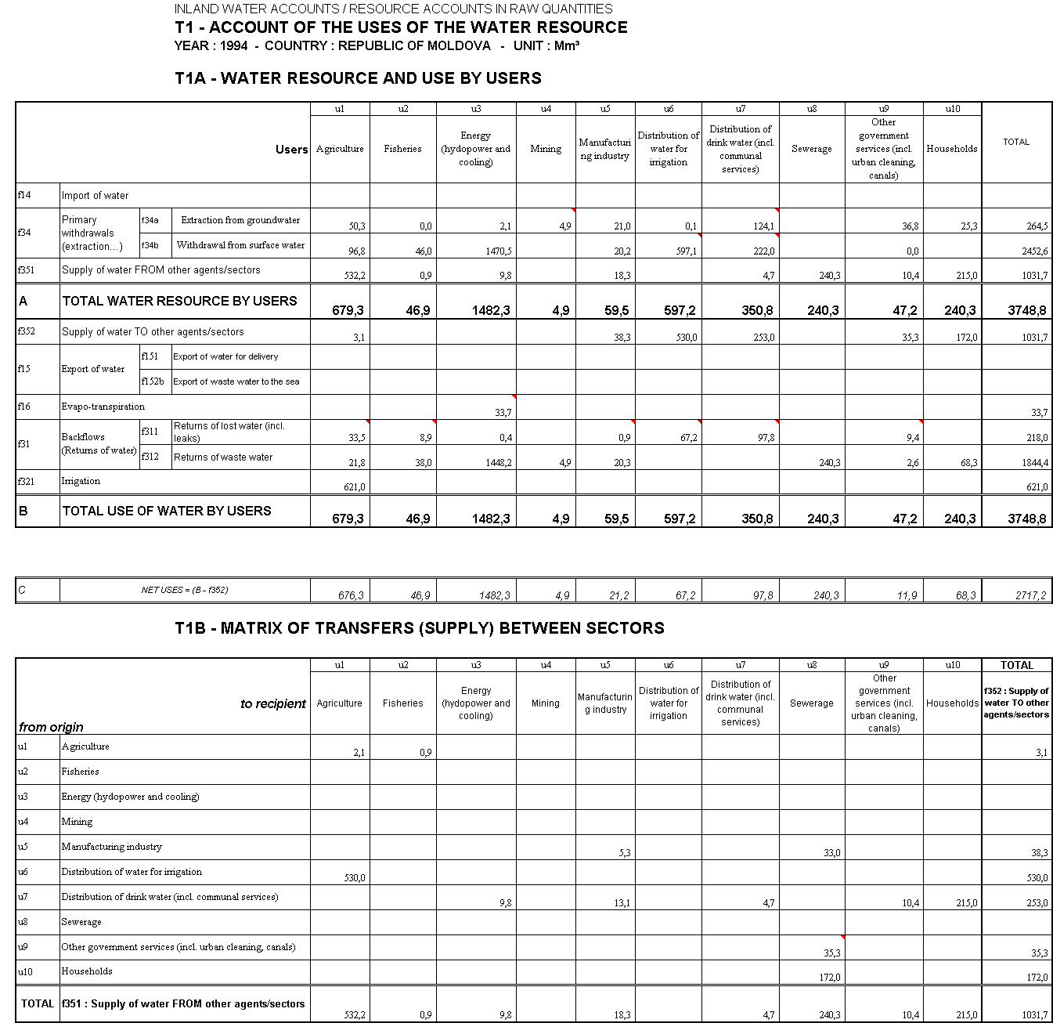

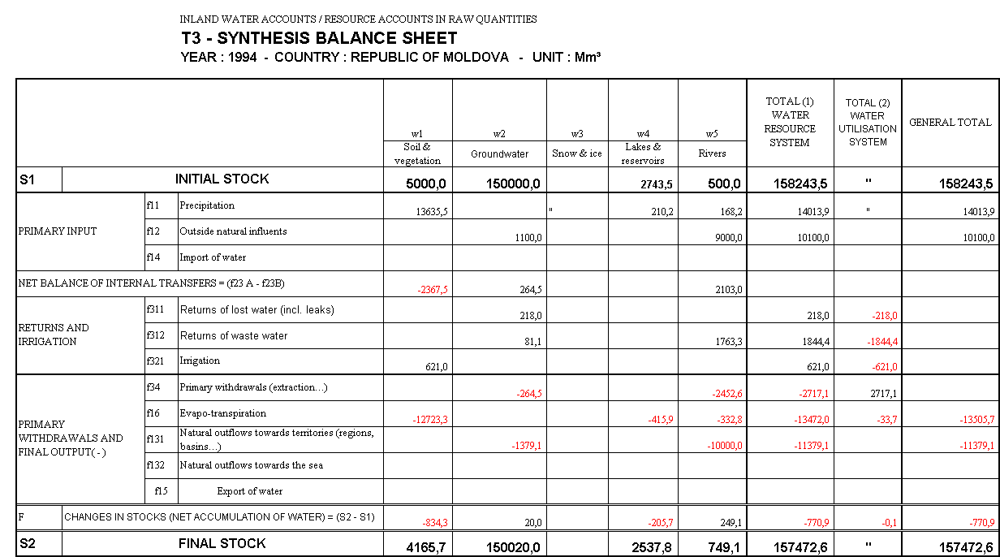

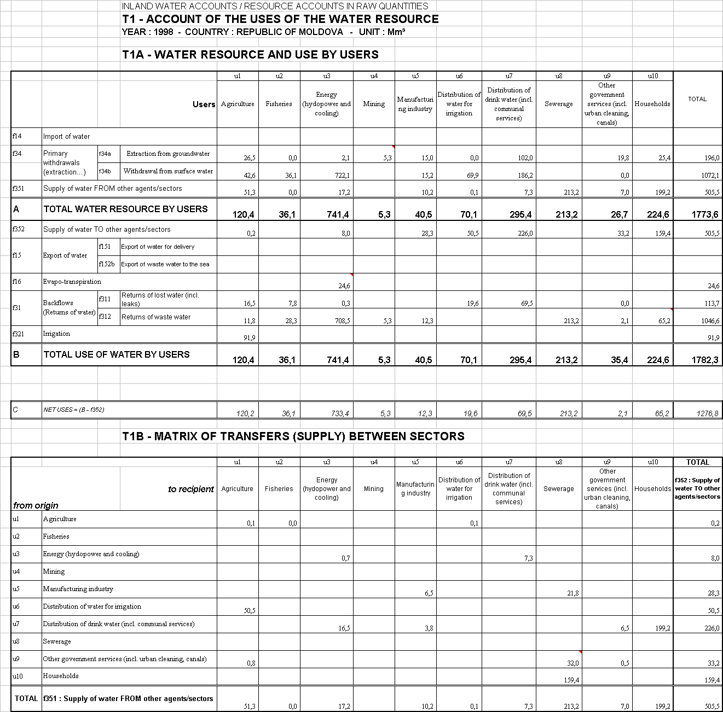

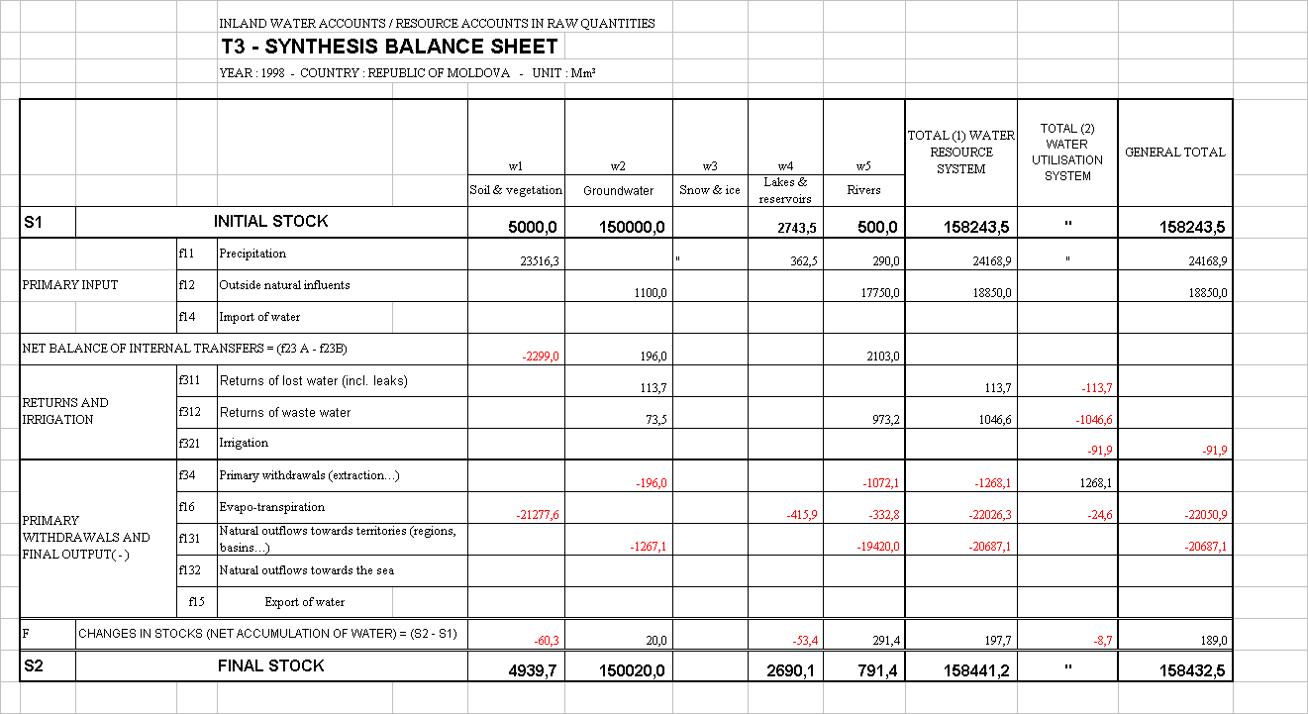

Annexe 2

 | INLAND WATER RESOURCE ACCOUNT CLASSIFICATIONS
 |  | CLASSIFICATION OF INLAND WATER SUB-SYSTEMS AND SECTORS
 |  | Level 1 |  |  |  |  | Level 2 |  |  |  |  |  |  |  | Other possible breakdowns
W |  | Hydrological System
w1 |  | Soil & vegetation
 |  |  |  | w11 |  |  | Soil
 |  |  |  | w12 |  |  | Vegetation
w2 |  | Groundwater
 |  |  |  | w21 |  |  | Variable stock
 |  |  |  | w22 |  |  | Permanent stock
w3 |  | Snow & ice
 |  |  |  | w31 |  |  | Snow
 |  |  |  | w32 |  |  | Ice (incl. glaciers)
w4 |  | Lakes & reservoirs
 |  |  |  | w41 |  |  | Lakes
 |  |  |  | w42 |  |  | Reservoirs (dams)
w5 |  | Rivers
 |  |  |  |  |  |  |  |  |  | w5a |  |  |  | Rivers, regular stream
 |  |  |  |  |  |  |  |  |  | w5b |  |  |  | Rivers, irregular stream
w9 |  | Atmosphere
U |  | Water Utilisation System
Nomenclature of Agents/Sectors (to be finalised)
 |  |  |  | u1 |  |  | Agriculture
 |  |  |  | u2 |  |  | Fisheries
 |  |  |  | u3 |  |  | Energy (hydopower and cooling)
 |  |  |  | u4 |  |  | Mining
 |  |  |  | u5 |  |  | Manufacturing industry
 |  |  |  | u6 |  |  | Distribution of water for irrigation
 |  |  |  | u7 |  |  | Distribution of drink water (incl. communal services)
 |  |  |  | u8 |  |  | Sewerage
 |  |  |  | u9 |  |  | Other government services (incl. urban cleaning, canals)
 |  |  |  | u10 |  |  | Households

 | CLASSIFICATION OF FLOWS FOR THE PHYSICAL ACCOUNTS OF THE WATER RESOURCE
 | Level 1 |  | Level 2 |  |  | Level 3 |  | Other possible breakdowns
F | Water flows
F1 | External exchanges (with territories or systems)
 |  | f11 | Precipitation
 |  | f12 | Natural inflows and outflows
 |  | f12 | Outside natural influents
 |  | f13 | Natural outflows
 |  |  |  | f131 |  | Natural outflows towards territories (regions, basins…)
 |  |  |  | f132 |  | Natural outflows towards the sea
 |  | f14 | Import of water
 |  |  |  | f141 |  | Import of water for uses
 |  |  |  |  |  |  |  | f141a |  | Import of drink water
 |  |  |  |  |  |  |  | f141b |  | Import of irrigation water
 |  |  |  |  |  |  |  | f141c |  | Other import of water
 |  |  |  | f142 |  | Import of waste water
 |  | f15 | Export of water
 |  |  |  | f151 |  | Export of water for delivery
 |  |  |  |  |  |  |  | f151a |  | Export of drink water
 |  |  |  |  |  |  |  | f151b |  | Export of irrigation water
 |  |  |  |  |  |  |  | f151c |  | Other export of water
 |  |  |  | f152 |  | Export of waste water
 |  |  |  |  |  |  |  | f152a |  | Export of waste water to other territories
 |  |  |  |  |  |  |  | f152b |  | Export of waste water to the sea
 |  | f16 | Evapo-transpiration
F2 | Natural internal flows
 |  | f21 | Natural increase
 |  | f22 | Natural final consumption
 |  | f23 | Spontaneous internal transfers
 |  |  |  | f231 |  | Surface transfers
 |  |  |  |  |  |  |  | f231a |  | Run-off
 |  |  |  |  |  |  |  | f231b |  | Flow-off
 |  |  |  |  |  |  |  | f231c |  | Natural surface storage
 |  |  |  |  |  |  |  | f231d |  | Overflow (flood)
 |  |  |  | f232 |  | Underground transfers
 |  |  |  |  |  |  |  | f232a |  | Seepage
 |  |  |  |  |  |  |  | f232b |  | Up-well discharge
 |  |  |  |  |  |  |  | f232c |  | Rise

F3 | Internal operations of the users
 |  | f31 | Backflows (Returns of water)
 |  |  |  | f311 | Returns of lost water (incl. leaks)
 |  |  |  | f312 | Returns of waste water
 |  | f32 | Artificial contribution (inflow) to the media
 |  |  |  | f321 | Irrigation
 |  |  |  | f329 | Other…
 |  | f33 | Internal engineering transfers (resulting from water management)
 |  |  |  | f331 | Direct internal engineering transfers
 |  |  |  |  |  | f331a | Transfers from drainage
 |  |  |  |  |  | f331b | Mines exhaustion
 |  |  |  |  |  | f331c | Others
 |  |  |  | f332 | Induced internal engineering transfers
 |  | f34 | Primary withdrawals (extraction…)
 |  |  |  |  |  | f34a | Extraction from groundwater
 |  |  |  |  |  | f34b | Withdrawal from surface water
 |  | f35 | Supply of water between sectors
 |  |  |  | f351 | Supply of water FROM other agents/sectors
 |  |  |  | f352 | Supply of water TO other agents/sectors

Annex 3 : Surveys by DASS-Moldova

Department of Statistical and Sociologic Analysis of the Republic of Moldova
Approved by the DSSA of the RM
Decision no. 109 of 26.11.99

Questionnaire on sellective survey

“Environmental Pollution by Households”

The main purpose of this survey is to study one of the most important actual problems – environmental protection.
Your answers will contribute to a wider estimation of the impact caused by socio-economic activities of households on the environment. The results of this survey will be used only for general statistical purposes, while the value of conclusions, made on the basis of this survey depend on your openess and appropriateness of your answers.
Please, read attentively the questions and the proposed answers, then chose the answer which corresponds with the real living conditions of your family. Please mark your answer by encircling the figure from the right of each answer.

Territorial Code⊥⊥⊥ Number of the household⊥⊥⊥⊥⊥

1. What water sourse is used by your household?
1) from central supply 1.1 4) from lake, river, or other water basins 1.4
2) from dicentralised supply 1.2 5) use imported water 1.5
3) from well 1.3 6) from other sources (please, specify) ________________ 1.6
2. Are the local wells and other water sources mentained in an adequate manner?
1) yes 2.1 3) no 2.3
2) not all 2.2 4) cannot answer 2.4
3. How much water to you use for the necessities of your household every day per person?
1) up to 50 l 3.1 4) 200,1-300 l 3.4
2) 50,1-100 l 3.2 5) 300,1-400 l 3.5
3) 100,1-200 l 3.3 6) more than 400 l 3.6
7) cannot answer 3.7
4. How much of the total water used every day is used for drinking and food prepapration purposes per person ?
1) up to 10 l 4.1 4) 50,1-70 l 4.4
2) 10,1-30 l 4.2 5) more than 70 l 4.5
3) 30,1-50 l 4.3 6) cannot answer 4.6

5. How much garbage is thrown per day (please, specify the amount in kg)?
1) solid__________________ 5.1 2) liquid_________________________ 5.2
6. Is your household suppplied with a place for garbage land fill?
1) yet, there is such a place 6.1
2) no, there isn’t such a place 6.2
3) cannot answer 6.3
6.1. If such a place exsists, is it possible to use it?
- Yes, there is such a posibility 6.1.1
- No, there isn’t such a possibility 6.1.2
6.2. If you do not throw the garbage in special place, please, provide the reasons for not doing so?
- this place is situated in a long distance from the household 6.2.1
- there access the this palce is difficult, the road is bad 6.2.2
- there are no tranportation means for garbage removal 6.2.3
- I throw the wastage near my household 6.2.4
- other (please, specify)____________________________________ 6.2.5
6.3. If there isn’t such a place, where do you throw the garbage?
- The garbage is collected in a centralized manner 6.3.1
- The garbage is thrown in occasional garbage places 6.3.2
- other (please, specify)_______________________________________ 6.3.3
7. Quantity of fuel used for hiting during the winter season (please, specify the quantity used per day)?
1) coal_______________ 7.1 2) fuel oil_______________________________________ 7.2
3) wood________________ 7.3 4) other (please, specify)____________________________ 7.4
8. Quantity of fuel used per day for the private vehicle?
1) 10 l 8.1 2) 20 l 8.2 3) 30 l 8.3 4) 40 l 8.4
5) 50 l 8.5 6) more than 50 l 8.6 7) cannot answer 8.7
9. In your opinion, does the level of environmental pollution have an impact on the health status of your family?
1) yes 9.1 2) no 9.2 3) cannot answer 9.3

THANK YOU FOR CO-OPERATION
Questionnaire for a selective survey
“Farmers’opinion on some environmental, social and economic problems”

Approved by the DSSA of the RM
Decision No. of

A. Environmental problems

1. What is the influence Considerable influence………1
of the environmental problems A certain influence……….…2
on your household? The influence is not observed practically….3
(for example environmental Cannot answer…………………...4
pollution)

2. At present the pesticides are widely used. Yes…………….1
Do you use pesticides, mineral or chemical No………2
fertilizers for cultivaton of plants? Don’t know……….3

3. Do you respect the norms and Yes…………….1
regulations while applying No…………....2
mineral or chemical fertilizers? Don’t know……….3

4. Use of water for irrigation
4.1 Do you use plumbing? Yes…………….1
No……….……2
4.2 The average amount of water, daily used
for irrigarion (please, specify the quantity in l/per day)?_____________

5. In production process, do you use Yes……….…….1

agriculture wastage? No…………….2

(seed wastage, corn wastage, beat leaves, Don’ know……..3

leaves of root plants and other wastages)

6. Do you plant or produce environmental Yes……………..1
friendly products? No……………..2
Don’t know……...3

7. Are you interested to produce purely Da……………..1
environmental friendly Nu…………….2
production? Don’t know……...3

B. Social and economic problems

8. Which of the folowing problems are actual (priority) for your household? Mark in each column by circle only one variant of the answer
most acctual acctual cannot answer
8.1. The legal framework on
your actual working conditions…………………..…1……….…1………..1
8.2.Problems related to receipt of credits
and payment of interests for the credits ……....2………….2………..2
8.3.Inflation rate ……………………………..…......3………….3………..3
8.4.Lack of technical means (tractors, agricultural machinery etc.)…...…4………….4………..4
8.5. Problems related to power supply …...…….…...5……..…...5..………5
8.6.Lack of necessary resources (fodder, seeds etc..6………...6…………6
8.7.Other resons_____________________…………7…..…….7…………7

9. What is the impact of the Contribute to the extension of activities of your household? ……1
Causes delays in the production and selling of production ………2
Cannot answer………...……3
10. What is your opinion about the selling prices on the agriculture products? (it is necessary to provide an answer for each option)

high accesibile low cannot answer
10.1.Cereals (including maize)………..1………...2……….3……….4
10.2. Sun-flower…………..…………..1…………2……….3……….4
10.3. Vegetables……………………....1…………2……….3……….4
10.4. Potatoes………………………....1…………2……….3……….4
10.5.Fruits and berries………………...1…………2…...…..3……….4
10.6. Grapes…………………………..1………….2……….3……….4
10.7. Other agriculture products (milk,
beef meat, pork meat).…………..1………….2……….3……….4

11. How much are you
concerned about the Very much concerned ………………....1
uncertainty in your future Concerned……………………….……..2
and unstable situation Practically not concerned………………3
in the society? Cannot answer……….….…………...…4

Department for Statistical and Sociological Research
Report is presented in accordance
with the law of Republic Moldova
for statistic. The entered data re
used only in statistical purposes.
1 | 2 | 3 | 4 | 5 | 6 | 7 | 8 | 9 | 10 | 11
Organization that reports according the Classifier: "Enterprises and Organizations". | Ministry (department) Concern, Association, according the Classifier COCM | Organization that reports according the Classifier: State Evidence of Water Use | Town, district according CUTAM classifier | The organizational - juridical form according classifier CFOJ | type of the organization's property according CFP | Main activity according CAEM | branch according to the classifier: The Branches of National Economy | of the sector of water's household |  | Sum for control (2+3+4+5+6+7+8+9)
 |  |  |  |  | Codes

Addressee _____________________________________________________________________ Approved by DSSR Decision,
Name Republic Moldova nr.46,
Ministry (department), Concern, Association, Founder__________________________________ Statistical questionnaire from 04.06.99
nr.1 - waters household
Enterprise ____________________________________________________________________ Presents the enterprises that use
Address ______________________________________________________________________ Water utilization for year 1999 water at 10 January:
The type of the property _________________________________________________________ (annual) 1."Moldova's water"
According the classifier of the types of property 2. Local agencies for ecology
of Republic Moldova 3. The Centraliser DSSR of RM
The organizational - juridical form __________________________________________________ presents to the Republic
According the classifier of the organizational - juridical Concern for Water house hold
forms from RM "Moldova's waters" at 20
March
Main activity according CAEM___________________________________________________

Branch according to the branch classifier____________________________________________

Report is presented for forms, form Nr.

The number of completed rows

Table 1. Water from natural sources, received from other enterprises (organizations) used and distributed

Row number | Issues name sources | Codes |  |  | Distance from the mouth, km | Taken or received in  total during  one year
Row number | Issues name sources | The type of sources or distributive enterprises | Aquatic objects (sources for water supplying) | The category of water quality | Distance from the mouth, km | Taken or received in  total during  one year
A | B | C | D | E | 1 | 2
1
2
3
4
5

Row number | Including for mount
Row number | January | February | March | April | May | June | July | August | September | October | November | December | Limit
A | 3 | 4 | 5 | 6 | 7 | 8 | 9 | 10 | 11 | 12 | 13 | 14 | 15
1
2
3
4
5

Row number | Used water |  |  |  |  |  |  | Distributed to other users |  |  |  | Wastes at the transportation
Row number | virtually | From which for other needs |  |  |  | Other needs |  | Without consumption |  | After consumption |  | Wastes at the transportation
Row number | virtually | For household and for drink | Production | For regulary irrigation | Agricultural units | Code | Quantity | Code | Quantity | Code | Quantity | Wastes at the transportation
A | 16 | 17 | 18 | 19 | 20 | 21 | 22 | 23 | 24 | 25 | 26 | 27
1
2
3
4
5

Table 2. The drainage system

The number of completed rows
Row number | Name of the receiver | Codes |  |  | The distance from the mouth | Used waters, escaped thousands cubic metres
Row number | Name of the receiver | The type of the receiver | Aquatic objects (water receivers) | The category of water quality | The distance from the mouth | Total | Polluted |  | Conventionally cleaned (not clean) | Conventionally cleaned at the cleaning installations
 |  |  |  |  |  |  | Without cleani- sing | Not enough cleaned | Conventionally cleaned (not clean) | biological | Physical- chemical | Mechanical
A | B | C | D | E | 1 | 2 | 3 | 4 | 5 | 6 | 7 | 8
21
22
23

Row number | The polluting substances contained in sewages that go in aquatic objects |  |  |  | The polluting substances in sewage that go in aquatic objects |  |  |  |  |  |  | Sum for control (13+…+19  9+…+19)
Row number | The biological consumption of the oxygen | The oil products | Suspended | Dry odes
A | 9 | 10 | 11 | 12 | 13 | 14 | 15 | 16 | 17 | 19 | 19 | 20
21
22
23

- The indexes in the columns 9, 10, 11, 12, sulfates and chlorides are presented in tones, other indexes: phonon, vanadium, bismuth, cadmium, mercury, silver, arsenic, magnum, nickel, plumb, formaldehyde, manganese (in columns 13, 14, 15, 16, 17, 18, 19) – in kg.

Table 3. Other indexes

Row number | The name of the indexes | The unit of measure | Code | Virtually
A | B | C | 1 | 2
31 | Water consumption in the systems with closed water supply | Thousands cubic meters | 0114
32 | Water consumption in the systems with repeated water supply | __,,__
33 | The reduction of sewage escape in comparison with the previous year | __,,__
34 | The established limits for water taking
35 | Including the underground waters
36 | The number of working days of the Consumer | Days | 0358
37 | The average number of working hours per day | Days | 0356
38 | The capacity of purifying installations, after the waters escape in pools of the irrigation fields
39 | Those ones that assure the purification in the limits of quality conciliations
40 | The capacity of purification stations, afterwards the waters escape of irrigable fields in pools, territory
41 | The cost of the valuable substances extracted from sewage – total
42 | From them oil products and oil
43 | The sum for control (31+32+33+34+35+36+37²+38+39+40+41+42²)

²⁾ Enterprises do not complete Note: The indicated values are presented with
the precision 0.1.
«______» _____________________199___
________________________________________ Leader
Name and telephone number of executor

Controlled and signed

The Head of the Section for administration of Water Sources of CRGA “Moldova′s Water”.

The Head of local agency for ecology.

Department for Statistical and Sociological research of the Republic Moldova
Data for identification Codes  Name  ___________________ Cod CUÎO  ___________________ |_|_|_|_|_|_|_|  Address  village (commune)______________ Cod CUTAM  (a completed by  municipal (district)______________ statisticians)  |_|_|_|_|  street_________________________  Nr._________apt._______________  The superior Cod COCM  organization___________ |_|_|_|_|_|  The form of the property (1) Cod CFP |_|_|  Cod CFOJ  The organizational - juridical form (2) |_|_|_|  Cod CAEM  Main activity (3) |_|_|_|_|_|  The cod of the form Cod CDUM |_|_|_|_|_|  Executor's name and accessories  Mr. (Mrs.)_____________________  tel. ___________________________  Leader  Chief accountant  »______»________________2000 | Statistical questionnaire nr.18-СС  (mail - annual)  Investments in the fixed capital for environment protection  for 1999 | In accordance to the “Law for Statistics′ of the Republic Moldova, State statistical institutions have the right to receive statistical reports from all the persons both natural and juridical being no dependent of the form of property.  Statistical offices assure the confidentiality of the data and individual information and use them only in statistical purposes.  Approved by DSSR of Republic Moldova by the Decision NR. 76 from 02.07.1999  It presents the building organizations and enterprises till 10 February the next year of the reported one.  - Local Statistical agencies.  - The hierarchic superior organization.

The name of the indexes | The row′s number | Units of measure | The functioning capacities according the approved reception acts |  | Investments in fixed capital, thousands, lei |  |  |  |  | From them assembling – building work, thousand lei
The name of the indexes | The row′s number | Units of measure | Total | from them the Fund for Ecology | Used during the reporting year |  |  |  | Used during the previous year - total | Used during the reporting year |  |  |  | Used during the previous year - total
 |  |  |  |  | Total | from the financed from |  |  | Used during the previous year - total | Total | from them financed by |  |  | Used during the previous year - total
 |  |  |  |  |  | The budget of the Republic | Local budget | The Fund for Ecology | Used during the previous year - total | Total | The budget of the Republic | The local budget | The Fund for nature protection | Used during the previous year - total
A | B | C | 1 | 2 | 3 | 4 | 5 | 6 | 7 | 8 | 9 | 10 | 11 | 12
The environment protection and rational use of the natural resources (the sum of rows 02, 25, 35, 50, 55, 65, 67, 69, 70, 75) - total | 01 | - | x | x
from them:  The protection and rational use of the water resources – total | 02 | - | x | x
Purifying stations for sewage (the sum of the rows 05, 06, 07) | 04 | thousands cubic metres/per day (sewage)
from them:  Stations of biologic purification | 05 | _»_
Stations of physical – chemical purification | 06 | _»_
Stations of mechanical purification | 07 | _»_

The name of the indexes | The row′s number | Units of measure | The functioning capacities according the approved reception acts |  | Investments in fixed capital, thousands, lei |  |  |  |  | From them assembling – building work, thousand lei
The name of the indexes | The row′s number | Units of measure | Total | from them the Fund for Ecology | Used during the reporting year |  |  |  | Used during the previores year - total | Used during the reporting year |  |  |  | Used during the previous year - total
 |  |  |  |  | Total | from the financed from |  |  | Used during the previores year - total | Total | from them financed by |  |  | Used during the previous year - total
 |  |  |  |  |  | The budget of the Republic | Local budget | The Fund for Ecology | Used during the previores year - total | Total | The budget of the Republic | The local budget | The Fund for nature protection | Used during the previous year - total
A | B | C | 1 | 2 | 3 | 4 | 5 | 6 | 7 | 8 | 9 | 10 | 11 | 12
from the rows column 04  The purifying stations of sewage at the working enterprises | 08 | thousands cubic metres/per day (sewage)
The purifying stations of communal water | 09 | _»_
from them:  the plants for biologic purification | 10 | _»_
Other plants for sewage purification | 11 | _»_
Plants for oil, black oil, rubbish and other liquid or solid odds collection from the rivers, or internal pools | 18 | units
The systems for water alimentation with closed circulation - total | 19 | thousands cubic metres/per day (circulation water
from them at the functioning enterprises | 20

The name of  the indexes | The row′s number | Units of measure | The functioning capacities according the approved reception acts |  | Investments in fixed capital, thousands, lei |  |  |  |  | From them assembling – building work, thousand lei
The name of  the indexes | The row′s number | Units of measure | Total | from them the Fund for Ecology | Used during the reporting year |  |  |  | Used during the previores year - total | Used during the reporting year |  |  |  | Used during the previous year - total
 |  |  |  |  | Total | from the financed from |  |  | Used during the previores year - total | Total | from them financed by |  |  | Used during the previous year - total
 |  |  |  |  |  | The budget of the Republic | Local budget | The Fund for Ecology | Used during the previores year - total | Total | The budget of the Republic | The local budget | The Fund for nature protection | Used during the previous year - total
A | B | C | 1 | 2 | 3 | 4 | 5 | 6 | 7 | 8 | 9 | 10 | 11 | 12
the atmospheric air protection - total | 25 |  | x | x
from them:  Plants for catching and neutralisation of harmful substances from the waste gases - total | 26  27 | Tonnes of harmful substances per year
 | 26  27 | thousands cubic metres per hour
from them at the functioning enterprises | 28  29 | Tonnes of harmful substances per year
from them at the functioning enterprises | 28  29 | thousands cubic metres per hour
Plants for control and regulation for the checking and the reduction of toxic, gases of the vehicles | 30 | units
Soil protection and rational use - total | 35 | - | x | x
from them:  The hidrotechnical buildings for the antierosional purpose | 36 | - | x | x

The name of  The indexes | The row′s number | Units of measure | The functioning capacities according the approved reception acts |  | Investments in fixed capital, thousands, lei |  |  |  |  | From them assembling – building work, thousand lei
The name of  The indexes | The row′s number | Units of measure | Total | from them the Fund for Ecology | Used during the reporting year |  |  |  | Used during the perverse year - total | Used during the reporting year |  |  |  | Used during the previous year - total
 |  |  |  |  | Total | from the financed from |  |  | Used during the perverse year - total | Total | from them financed by |  |  | Used during the previous year - total
 |  |  |  |  |  | The budget of the Republic | Local budget | The Fund for Ecology | Used during the perverse year - total | Total | The budget of the Republic | The local budget | The Fund for nature protection | Used during the previous year - total
A | B | C | 1 | 2 | 3 | 4 | 5 | 6 | 7 | 8 | 9 | 10 | 11 | 12
Antiavalanche and antilandslide buildings | 37 | - | x | x
Plants for banks consolidations | 38 | km
The terracing of the abrupt slopes | 41 | ha
The creation of protection forest plantations | 42 | ha
from them the creation of field protection zones | 43 | ha
The lands recultivation | 44 | ha
The protection and rational use of forest resources | 50 | - | x | x
The protection and the reproduction of fish resources – total | 55 | - | x | x
From them:  fish – bearing enterprises | 56  57 | millions pieces of fish

The name of  The indexes | The row′s number | Units of measure | The functioning capacities according the approved reception acts |  | Investments in fixed capital, thousands, lei |  |  |  |  | From them assembling – building work, thousand lei
The name of  The indexes | The row′s number | Units of measure | Total | from them the Fund for Ecology | Used during the reporting year |  |  |  | Used during the perverse year - total | Used during the reporting year |  |  |  | Used during the previous year - total
 |  |  |  |  | Total | from the financed from |  |  | Used during the perverse year - total | Total | from them financed by |  |  | Used during the previous year - total
 |  |  |  |  |  | The budget of the Republic | Local budget | The Fund for Ecology | Used during the perverse year - total | Total | The budget of the Republic | The local budget | The Fund for nature protection | Used during the previous year - total
A | B | C | 1 | 2 | 3 | 4 | 5 | 6 | 7 | 8 | 9 | 10 | 11 | 12
Plants for fish protection | 58 | units
Plants for production wastes use and processing (excluding factories and enterprises that process and burn the rubbish, the enterprises that use, neutralise and warehouse the industrial and consumption toxic wastes) | 64  65 | units  thousands tonnes per year
Enterprises and polygons for the use, neutralisation and warehousing of the production and consumption toxic wastes | 66  67 | units  thousands tonnes per year
The organization of the natural reservations and other nature protection zones | 69 | - | x | x
The underground protection and rational use | 70 | units
The animal and bird protection and reproduction | 75 | - | x | x

¹⁾ On the 70th row, column 1, are indicated only functioning plants and buildings for the complex use of mineral resources, but on the rows 3 – 12 the expenditures for all the objects for underground protection and rational use of mineral resources.

Department for Statistical and Sociological research of the Republic Moldova

Data for identification Codes  Name  ___________________ Cod CUÎO  ___________________ |_|_|_|_|_|_|_|  Address  village (commune)______________ Cod CUTAM  (a completed by  municipal (district)______________ statisticians)  |_|_|_|_|  street_________________________  nr._________apt._______________  The superior Cod COCM  organization___________ |_|_|_|_|_|  The form of the property (1) Cod CFP |_|_|  Cod CFOJ  The organizational - juridical form (2) |_|_|_|  Cod CAEM  Main activity (3) |_|_|_|_|_|  The cod of the form Cod CDUM |_|_|_|_|_|  Executor's name and accessories  Mr. (Mrs.)_____________________  tel. ___________________________  Leader  The main accounter | Statistical questionnaire nr.1  (annual)  Current expenditures for nature protection  for 199__ | According to Statistic's Low of the Republic Moldova, the state statistical institutions have the right to receive statistical reports from all the persons both natural and juridical having no matter with the form of the property.  Statistical institutions assure the confidentiality of the data and individual information. The data are used only in statistical purposes.  Approved by DSSR of Republic Moldova by the Decision NR. 46 from 04.06.1999  Presented at 25 of February by the enterprises, organizations having purifying installations that execute expenditures of environment protection.  - Local Statistical Unit.  - Local Agency for Ecology

The row's code | The specification of current expenditures | Virtually for the year, lei
A | B
010 | Chapter 1  Current expenditures for environmental protection - total (020+030+040+050)
020 | from them:  for protection and rational use of water resources
021 | from them for remuneration of other enterprises for reception and purification of sewage
030 | for atmospheric air protection
040 | for soil protection from pollution with production and consumption waste products
041 | from them paid to other enterprises and organizations for waste receiving, ware housing and destroying
050 | for soil recultivation
060 | Current expenditures for capital reparations of stable production funds for environment protection - total
061 | from them:  plants for catching and neutralization of harmful substances from waste gases
062 | plants for sewage purification and rational use of water resources
070 | Note:  Annual average value of stable funds of production for environment protection
071 | from them:  for protection and rational use of water resources
072 | for atmospheric air protection
099 | The sum for control

The row's code | Name | Calculated, lei | Virtually  paid, lei
A | B
080 | Chapter II  Enterprises payments for environmental pollution  Payment for emission (escape, warehousing) in admissible limits of harmful substances (wastes) - total
081 | from them:  water object
082 | in atmospheric air
083 | for wastes
090 | Payment for the supernormal emission  (escape, warehousing) of harmful substances (waste) - total
091 | including:  water objects
092 | in atmospheric air
093 | for wastes
100 | Penalties for the breach of establishments concerning environment protection (for environment pollution and accidents) - total
101 | from them:  concerning atmospheric air protection
102 | concerning water resources protection
103 | concerning soil protection
999 | The sum for control

Explanation at the report ___________________________________________________

« _____» _____________________ 199____

Controlled and signed

The Head of the Local agency for ecology

Prepared by Jana Tafi (DASS/Moldova) & Jean-Louis Weber (IFEN/France)
These surveys have been realised in the context of the TACIS Project « Environment Statistics » (MD92FR01) worked out by EUROSTAT and DASS-Moldova with the co-operation of Insee & Ifen-France.
From Crouzet Ph. and Weber J.-L., Papers of the MEDSTAT-F3 Training Session, Blue Plan & Eurostat, Cannes, 28 June-4 July, 2000.
Crouzet, Ph., Water Quality Key Concepts, in Papers of the MEDSTAT-F3, op. quoted
in Crouzet, op. quoted
Naredo, J.-M. & Gasco, J.-M., The Accounts of Water in Spain, Synthesis Report, room document, OCDE 1994. A presentation of the methodology is made by Jiliberto, R. & Alvarez-Arenas, M. in a draft note for Eurostat’s Task force on water accounting, 1997. They write : “Water accountancy in Spain approaches the problem of quality accounting by identifying the «natural» quality of water with the «amount of free energy that could be liberated from it», or with the «energetic cost to transform it into the desired quality level from sea water». This concept is linked to energy water accountancy. High quality energy forms would be: - Hydraulic potential. This is understood as the energy that can be liberated by a mass of water in free fall, associated with gravity(g) and height (h). In regions with an abrupt landscape, like Spain, this potential is incredibly important. - Osmotic potential. This is associated with the osmotic dissolving power of water, which is maximal in rain water and minimal at the mouth of a river. These two potentials follow a decreasing gradient from the source (higher altitude, less salty waters) to the mouth. This general rule can be altered sometimes in the main courses for the osmotic potential, when close to the sea less salty tributaries dilute the water of the main river. The advantage of this approach is that quality is expressed in energetic units, and so partial accounts can be added up. This allows the development of a true accountancy of quality (or better, of the non-liberated energy of water).”
COMMISSION INTERMINISTERIELLE DES COMPTES DU PATRIMOINE NATUREL, Les comptes du patrimoine naturel, Collections de l'INSEE, C137-138, Paris, 1986.
This system analysis is the one which is behind the framework developed by the French Natural patrimony accounts - See , Les comptes du patrimoine naturel, op. cit. (Chapter 5, drafted by Jean Margat)
When these taxes are based on production, it requires eliminating double accounting in the producer and financing sector accounts.
In particular, it was possible to use data compiled in the report on « NATIONAL WATER RESOURCES MANAGEMENT STRATEGY - APELE MOLDOVEI / Tahal Consulting - March 1997 »
Sociological sample survey on “environmental pollution by households” worked out by DASS in December 1999 in the framework of this TACIS “environmental statistics “ project on a sample of 420 households (1405 persons, of which 879 from rural areas).

